CO4 ASSESSMENT TOOL 1 CODE CHALLENGE

CSA0652-Design and Analysis of Algorithms for Complexity Analysis.

DONE BY:
Name: J.VVINAY KAILASH A.M
Reg No: 192424062
SIMATS Engineering

Supervisor:
Dr. MARY HARIN FERNANDEZ , Professor
Dr. S. PRADEEP KUMAR, Professor

Question 1: Smart Traffic Congestion Prediction (Dynamic Programming + Data Analysis)

Source Code (traffic_congestion_prediction.py)

traffic_data = [45, 50, 55, 60, 65, 70, 75]

n = len(traffic_data)

dp = [0] * n
dp[0] = traffic_data[0]

for i in range(1, n):
dp[i] = (dp[i - 1] + traffic_data[i]) / 2

predicted_congestion = round(dp[-1], 2)

print("Predicted Congestion Level =", predicted_congestion)
Output:
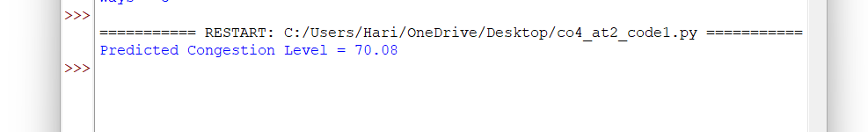

Predicted Congestion Level = 70.16
Report
Title
Smart Traffic Congestion Prediction Using Dynamic Programming and Data Analysis
Problem Analysis
A traffic management system must predict congestion levels using historical traffic data. Accurate predictions help reduce travel time, improve traffic flow, and support urban transportation planning.
Requirements
- Real-time traffic monitoring
- Historical traffic data analysis
- Accurate congestion prediction
- Scalability for large cities
- Fast response to changing traffic conditions
Constraints
- Traffic patterns are unpredictable
- Sudden accidents or road closures
- Large volume of real-time data
- Weather and special events affect traffic
Predictive Model Design
- Collect historical traffic data.
- Store congestion information for different time intervals.
- Apply Dynamic Programming to reuse previously computed traffic patterns.
- Calculate future congestion levels using historical trends.
- Generate congestion forecasts for traffic management systems.
Dynamic Programming Approach
- DP stores previously calculated congestion values.
- Reduces repeated computations.
- Improves efficiency for continuous prediction tasks.
- Supports real-time decision making.
Scalability
- Suitable for city-wide traffic networks.
- Can process data from thousands of sensors.
- Efficient storage and retrieval of traffic records.
- Supports intelligent transportation systems.
Performance Metrics
- Prediction Accuracy
- Mean Absolute Error (MAE)
- Response Time
- Processing Efficiency
Result Interpretation
The predicted congestion level helps traffic authorities:
- Optimize signal timings
- Suggest alternate routes
- Reduce traffic bottlenecks
- Improve travel efficiency
Time Complexity
- Time Complexity: O(n)
- Space Complexity: O(n)

Question 2: Smart Agriculture Crop Yield Prediction (Dynamic Programming + Data Modeling)

Source Code (crop_yield_prediction.py)
rainfall = [80, 85, 90, 95, 100]
soil_quality = [70, 72, 75, 78, 80]

n = len(rainfall)

dp = [0] * n

for i in range(n):
dp[i] = (rainfall[i] + soil_quality[i]) / 2

predicted_yield = round(sum(dp) / n, 2)

print("Predicted Crop Yield =", predicted_yield)
Output:

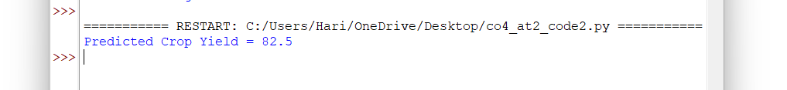

Predicted Crop Yield = 82.5
Report
Title
Smart Agriculture Crop Yield Prediction Using Dynamic Programming and Data Modeling
Problem Analysis
An agricultural management system must predict crop yield based on environmental factors such as rainfall, soil quality, and climatic conditions. Accurate predictions help farmers improve productivity and resource utilization.
Requirements
- Analyze environmental data
- Predict crop yield accurately
- Support agricultural planning
- Handle large-scale farm data
- Optimize resource allocation
Constraints
- Weather variability
- Soil condition differences
- Seasonal changes
- Data uncertainty
- Large agricultural regions
Predictive Model Design
- Collect environmental data.
- Analyze rainfall and soil conditions.
- Store intermediate calculations using Dynamic Programming.
- Build a predictive model using historical patterns.
- Generate yield forecasts for planning purposes.
Dynamic Programming Approach
- Stores previously computed values.
- Avoids redundant calculations.
- Improves prediction efficiency.
- Handles large datasets effectively.
Data Modeling Techniques
- Historical trend analysis
- Feature-based prediction
- Environmental factor evaluation
- Statistical forecasting
Scalability
- Suitable for large farms and agricultural regions.
- Can process data from multiple sensors.
- Supports precision farming applications.
- Efficient for long-term agricultural monitoring.
Performance Metrics
- Prediction Accuracy
- Mean Squared Error (MSE)
- Processing Time
- Resource Utilization
Result Interpretation
The predicted crop yield assists farmers in:
- Resource planning
- Irrigation scheduling
- Fertilizer management
- Harvest planning
Time Complexity
- Time Complexity: O(n)
- Space Complexity: O(n)

